**FUNDAMENTAL OF MANAGEMENT**



**PROJECT:**

**MCB BANK**

**Group number 2**

**Group Members:**

* Ibrar Babar (19P-0104)
* Asjid Tahir (p19-0085)
* Usman Manzoor (p19-0068)
* Umar Farooq (p19-0065)

**(Introduction):**

MCB Bank is one of the oldest banks of Pakistan and was incorporated in private sector in **1947**. It was nationalized in **1974** and privatized in **1991**.The Bank operates a strong and vast network of over **1,400** Branches and over **1,350** ATMs in Pakistan and **11** branches overseas with a footprint in UAE, Bahrain and Sri Lanka. . In **2015**, MCB Bank launched its first wholesale banking branch in the UAE.

**Permissible Activities:**

[Permissible Activities](https://www.mcb.com.pk/assets/documents/MCB_Permissible_Activities.pdf)

**Company Status:**

Public Limited Company. Listed on Pakistan Stock Exchange.

**Group companies:**

### Subsidiary Companies

* MCB Financial Services Limited.
* MCB Islamic Bank Limited.
* MCB Arif Habib Savings & Investments Limited.
* MCB Non-Bank Credit Organization” Closed Joint Stock Company”.

**(Managers)**

* Top Level manager
* Middle managers
* First line managers

**Top Level manager:**

[**Imran Maqbool**](https://www.google.com.pk/search?sxsrf=ALeKk00qWD2Tks3R5Fw1Sk5L-wUl_slyLA:1601495988884&q=Imran+Maqbool&stick=H4sIAAAAAAAAAONgVuLVT9c3NEwuMC02NDMufsRowS3w8sc9YSn9SWtOXmPU5OIKzsgvd80rySypFJLmYoOyBKX4uVB18ixi5fXMLUrMU_BNLEzKz88BAAmRYTdcAAAA) Is the CEO of MCB Bank all over the Pakistan. Also he is the included the top most leveled manager of the world.

**Middle managers:**

In this organization there is a branch manager how is come in middle managers, who manage the internal and external things of branch.

**FirstLineManagers:** The Operational manager who manage all the empoyees working and there issues, problems etc. Also operational manager have to manage the tea boys, the workers. Any kind of issue in the branch, like electricity issue etc have to be managed by operational manager.

**(Efficiency)**

Efficiency & Effectiveness is concerned with MCB Banking system.

**How MCB Bank is Efficient & Effective…????**

* **Integrity:**

**MCB** are the trustees of public funds and serve our community with integrity. MCB bank deliver on our responsibilities and commitments to our customers as well as our colleagues.

* **Innovation:**

MCB teams work together for the smooth and efficient implementation of ideas and initiatives.

* **Excellence:**

MCB take personal responsibility for our role as leaders in the pursuit of excellence.

* **Customer Centricity:**

MCB customers are at the heart of everything we do. MCB thrive on the challenge of understanding their needs and aspirations, both realized and unrealized.

* **Respect:**

MCB respect our customers’ values, beliefs, culture and history. We value the equality of gender and diversity of experience and education that our employees bring with them.

* **Goal of MCB Bank:**

Our customers are at the heart of everything we do. We thrive on the challenge of understanding their needs and aspirations, both realized and unrealized.We make every effort to exceed customer expectations through superior services and solutions

* **Vision Statement:**

To be the leading financial services provider, partnering with our customers for a more prosperous and secure future.

* **Mission Statement:**

MCB are a team of committed professionals, providing innovative and efficient financial solutions to create and nurture long-term relationships with our customers.

In doing so, we ensure that our shareholders can invest with confidence in us.

**(Achieve Goal through)**

**Planning:**

Defining goals, establishing strategies to achieve goals, developing plans to integrate and coordinate activities.

**Organization:**

Arranging and structuring work to accomplish organizational goals.

**Leading:**

Working with and through people to accomplish goals.

**Controlling:**

Monitoring, comparing, and correcting work.

**SKILLS:**

These are the top most management skills:

* Interpersonal skills.
* Communication and motivation.
* Organization and delegation.
* Forward planning and strategic thinking.
* Problem solving and decision-making.
* Commercial awareness.
* Mentoring.

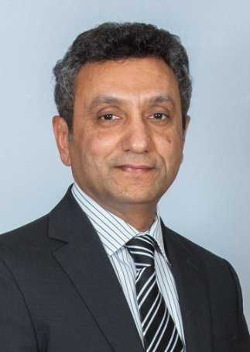**Top Managers (CEO):**

**Mr. Imran Maqbool** serves as **President & Chief** **Executive Officer** of MCB Bank Limited. Before taking on the **CEO** position, he was Head of Commercial Branch Banking Group.

He has professional management skills, because he had an experience in managing, largest group of the Bank in terms of market diversity, size of workforce, number of branches on countrywide basis and diversified spectrum of products. Although he get experience from many fields in which he have worked in management field.

**Middle Manager:** The manager of MCB bank have perfect ability to work well with other people. He is very cooperative in managing with his client also have good experience to work to manage a Bank. Also he is very cooperative with his employees.

**Employees:**

Employeesrespect our customers’ values, beliefs, culture and history. We value the equality of gender and diversity of experience and education that our employees bring with them.

**The Increasing Importance of Customers:**

MCB customers are at the heart of everything we do. MCB respect our customers values, beliefs, culture and history. MCB take personal responsibility for our role as leaders in the pursuit of excellence. Through these, MCB increase the importance of customer.

 **MCB (A Traditional Organization):**

* MCB is a stable organization.
* MCB is job focused organization.
* Managers always make decisions by getting a proper meeting with all employees.
* MCB is skill focused organization.
* MCB is temporary & Permanent job facility organization (Depends upon skills).
* MCB is customer–oriented organization.
* Employees of MCB are hard working. (If they don’t hard work then depending upon situation, they will be fired).

**(Principle of management)**

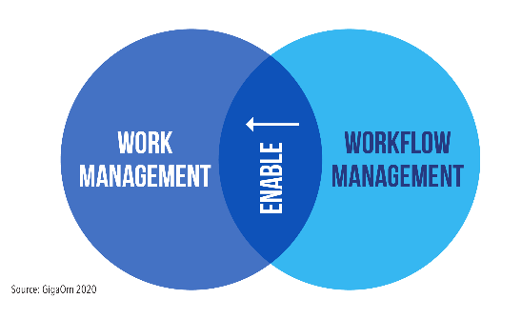

**Division of work:**

There are 1400 branches of MCB. The work is properly divide. First of all bank work of every area is divided into Branches. Each branch of MCB have a **Branch manager**, then on 2nd number there is operational manager who divide the further work of a branch into employees etc. So there is proper division of work.

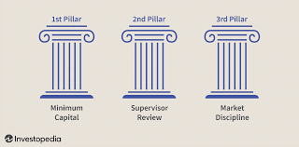**Discipline:**

* Clean environment.
* Better work place
* Hard working all staff (manager, operational manager, employees etc.)
* Each and everything is done in in a specific discipline.

**Unity of Direction:**

Unity of discipline is very contiguous in MCB bank. Every branch of MCB is linked with each other and the division of proper work is done by proper arrangement equally. In Peshawar Branch the division of work is equally be done by operational manager.

**(DIVION OF WORK IN MCB BANK)**

Division of work in MCB bank is properly divide.

**Manager:**

It has to manage all direct & indirect expects of branch. He have to manage operational manger, and all his employees. He have well experience to manage all them all as he also have a work experience as an **employee**. So he can manage all type of things.

**Operational manager:**

It has to manage all his employees working well or not. Also he have to work internal problems, like **tea boys**, **workers** in a branch.

**Cashiers:**

It has to deal with customers.

**Behaviors with Customers:**

MCB customers are at the heart of everything we do. MCB thrive on the challenge of understanding their needs and aspirations, both realized and unrealized. MCB respect our customer values, beliefs, culture and history. So Behaviors with customer is well mannered. The first thing is to respect them solve their problems. If an employee disrespect with customer and his values, then a strong action is to be done against him.

**(Culture Management)**

**Management Systems** defines an organization’s culture as consisting of the values, beliefs and norms which influence the behavior of people.

**Factors:**

Following are the factors which affect the whole management system:

* **Customer-Client Orientation**:

The way the **MCB bank** thinks about and treats its customers.

* **People Orientation or Orientation Towards Employees**:

It is the way the **MCB** bank thinks about and treats its people.

* **Standards of Performance and Accountability**:

The MCB’s standards for performance and what people are held accountable for.

* **Innovation and Commitment to Change**:

How the **MCB** views, reacts to, and manages innovation and change.

* **MCB Process Orientation**:

The view that people in the MCB have of such processes as planning, decision making, communication, and what we term “**corporate citizenship**” or “**social responsibility**.”

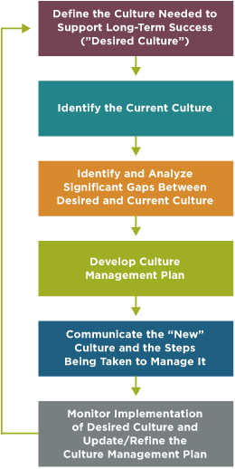”

**(Strong Culture)**  
A strong culture is one where all employees understand and behave in ways consistent with company values, beliefs and norms. It is also called **“Functional Culture**”.

**How MCB Strong Culture…..???**

* Core values.
* How you work together.
* Office Layout.
* Communication.
* Community Sense.
* Unified Purpose.
* Recognition.
* Connection.
* Learning and Development.
* Listening and Adapting.

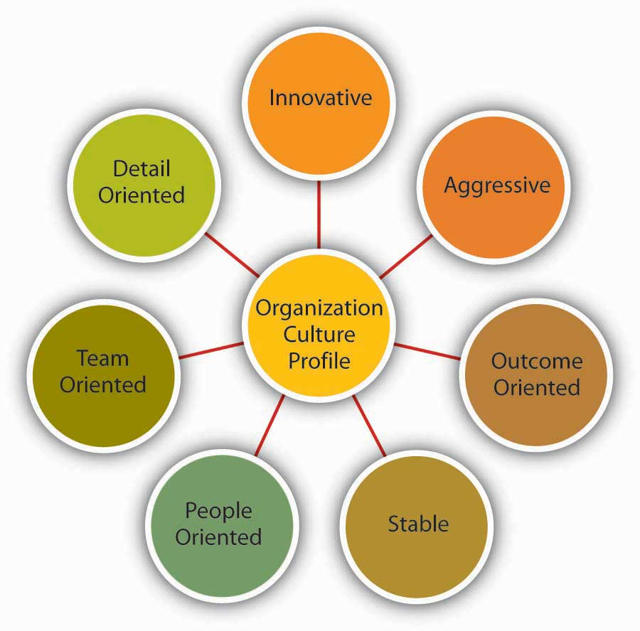



**Environment:**

An **Environmental Management System** (EMS) is a set of processes and practices that enable an organization to reduce its **environmental** impacts and increase its operating efficiency.

**Factors:**

Following are the factors that affect the whole environment of **MCB** Bank:

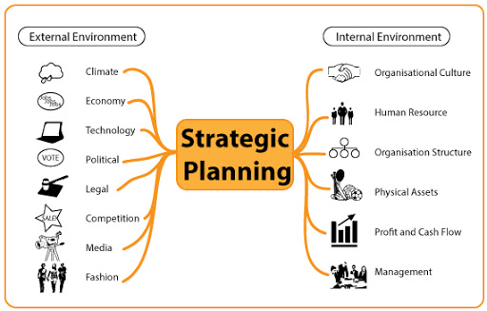**Competitors:**

Any person or entity which is a rival against another. In business, a company in the same industry or a similar industry which offers a similar product or service. Competition also requires other banks to become more efficient in order to reduce costs. So, there are many other banks which are the competitors against us.

* MEEZAN Bank.
* HABIB Limited Bank.
* ALLIED Bank.

**Whole Competitor System:**

MCB competitor could be a new business offering a substitute or similar product that makes your own redundant.

Competition is not just another business that might take money away from you. It can be another product or service that's being developed and which you ought to be selling or looking to license before somebody else takes it up.

And don't just research what's already out there. You also need to be constantly on the lookout for possible new competition

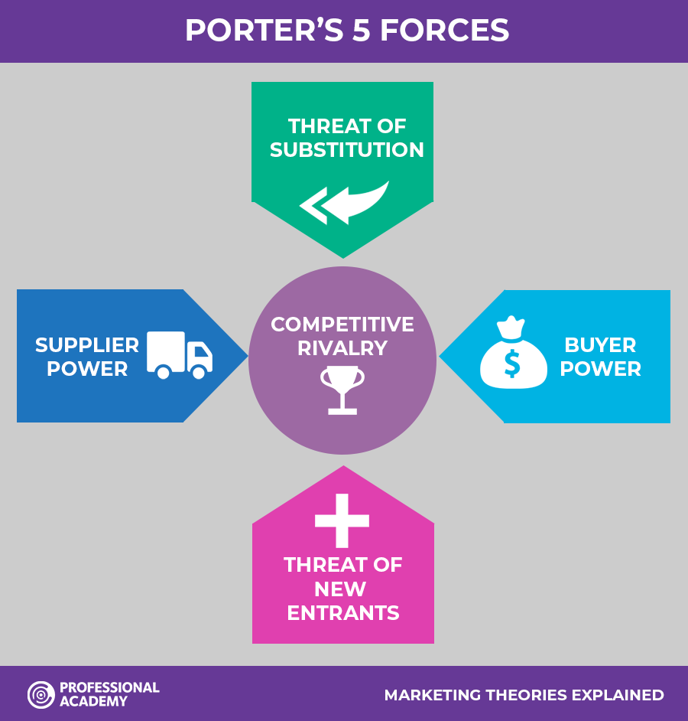

**(CONCLUSION)**

In everything like business, Jobs etc, there Is a competition in market which is never ends because it Is compulsory everyone wishes that they comes at number one in their related field so it is natural.

So, we can say that:

**“COMPETITION NEVER ENDS, Just try to improve yourself better day by day”.**